# Super Smash Potatoes

maybe update this picture to a screenshot? xD

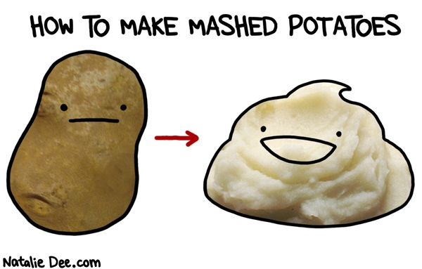

***The best game to have a playable potato.***

Benji Campbell, Adam Fořt, Sam Hibbert, Huw Tingley

Contents

Super Smash Potatoes 1

Overview 3

Theme 3

Targeted platforms 3

Target Demographics 3

Visual Style 3

Project Scope 4

Game Time Scale 4

Team 4

Game Flow 5

The Elevator Pitch 6

Project Description: 6

Gameplay 7

Gameplay (Brief) 7

Gameplay (Detailed) 7

Controls 8

Xbox Controller 8

Arcade Machine 9

UI 10

Camera 10

Level Editor 10

Arenas 10

Arena 1: 10

Arena 2: 11

Arena 3: 11

Unique Character Abilities 11

Assets Needed 12

- 2D 12

- Particles 12

- Sound 12

- Animation 12

## Overview

### Theme

Super Smash Potatoes will be a 2D platform fighting game- heavily inspired by the Nintendo game ‘Super Smash Bros.’

### Targeted platforms

- Computer

- UWE Arcade Machine

### Target Demographics

This game should be very accessible and enjoyable to all, the age range being from 6 years old upwards. The game will only be available in the UK, so the game will only have to be localised in English.

### Visual Style

The game will use a smooth-looking cartoony graphical style.

Example Assets:

Platform-



Character-



Background-

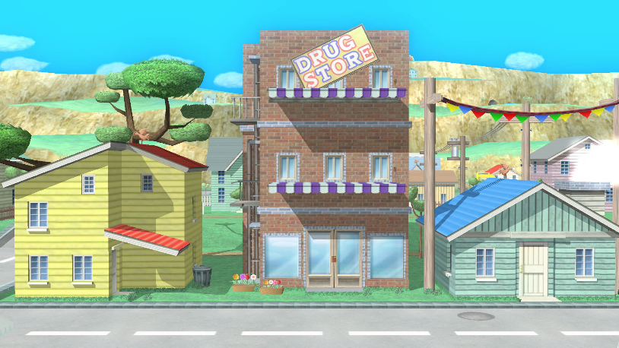

## Project Scope

### Game Time Scale

The games’ development will run from the beginning of February until the 17th of May. This also include the development of the engine required for the game.

### Team

There are 4 team members:

#### - Benji Campbell

Responsible For:

* Example
* Example2
* Fill out your own thingy, Remember it’s the game stuff not the proper engine stuff!

#### - Adam Fořt

Responsible For:

* Example
* 3 Player Ticks
* Fill out your own thingy, Remember it’s the game stuff not the proper engine stuff!

#### - Sam Hibbert

Responsible For:

* Example
* Example2
* Fill out your own thingy, Remember it’s the game stuff not the proper engine stuff!

#### - Huw Tingley

Responsible For:

* User Interface
* Inputs & Arcade Machine Port
* Audio (code)
* Menus
* Multiple Controller Support

## Game Flow

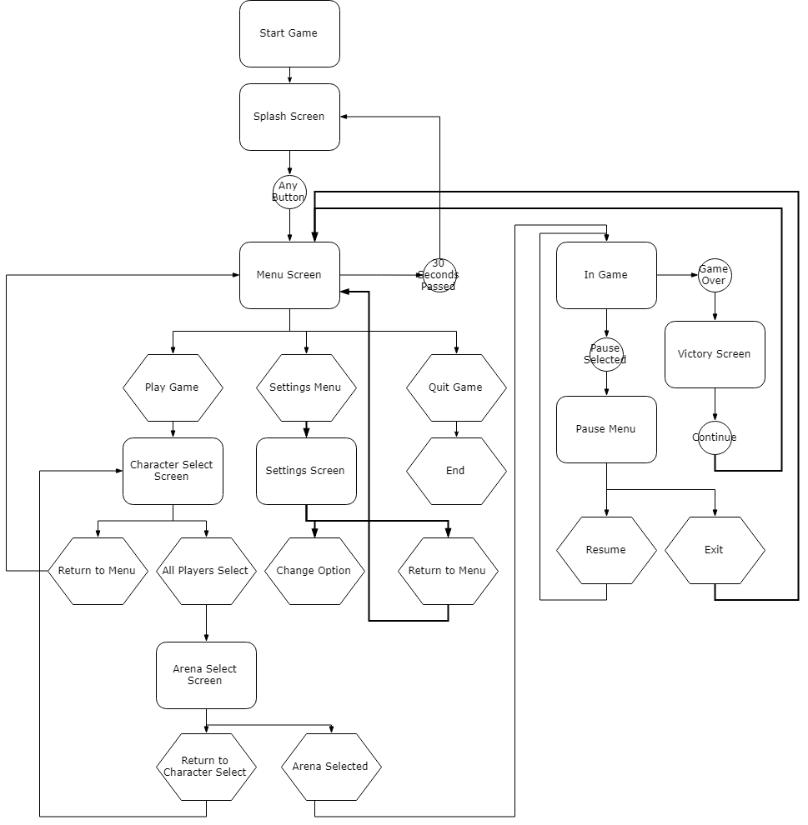

## The Elevator Pitch

Smash Bros but with a playable potato.

## Project Description:

Super Smash Potatoes follows in the vein of Super Smash Bros. where instead of killing an enemy by reducing their health to zero- instead players must hit their opponents out of the arena.

Players have a damage percentage that increases whenever they are hit by an opponent. This percentage subsequently increases the force that they will be pushed with when they are next attacked- making it easier to be forced out of the arena.

Each player will have a set amount of lives, and once those lives are all used up they will no longer respawn. The last player standing shall be proclaimed the winner.

## Gameplay

### Gameplay (Brief)

The Player is seeking to hit other players out of the bounds of the arena they are fighting in, trying to become the last man standing so that they may claim victory. The player must use the map, their abilities and items to defeat their opponents.

### Gameplay (Detailed)

#### Player Abilities

Punch

The punch is the players standard move, it hits nearby enemies in the direction which the player is facing- increasing the damage percentage on their opponent.

Up-Punch

The up-punch can be used for 2 different reasons:

Firstly, it can be used to punch and deal damage to enemies above the player.

Secondly, it can act as a double jump- repositioning the player more easily or saving them from falling out of the arena,

Down-Slam

This ability gives the players a way to deal damage from above,

causing their character to dive straight down and hit all enemies that they land near, pushing them away from the impact point and increasing their damage percentage.

Special

I know nothing about this

#### Items



Bomb

Bombs can be picked up by the player and thrown at their enemies, creating an explosion on impact that launches characters into the air and increasing their damage percentage.

Item 2

Item 3

## Controls

### Xbox Controller

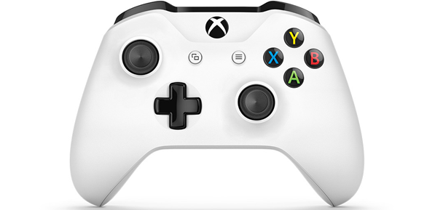

|  |  |
| --- | --- |
| Controls | Actions |
| Left Joystick (Left + Right) | Move Character Left and Right |
| A | Jump |
| X | Punch/Use Item |
| A + Left Joystick Down | Drop Platform |
| X + Left Joystick Up | Up-Punch |
| X + Left Joystick Down | Down-Slam |
| Start | Pause |

### Arcade Machine

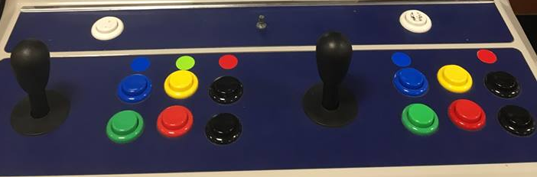

|  |  |
| --- | --- |
| Controls | Actions |
| Joystick (Left + Right) | Move Character Left and Right |
| Blue Button | Jump |
| Green Button | Punch/Use Item |
| Blue Button + Joystick Down | Drop Platform |
| Green + Joystick Up | Up-Punch |
| Green + Joystick Down | Down-Slam |
| Black | Pause |

## UI

The in-Game HUD UI will display up to 4 players’ (2 for Arcade Machine) character representation, damage percentage and lives remaining. The UI also displays the time remaining until the game ends.

## Camera

A dynamic camera system will follow the action- zooming in and out to focus on the combat whilst making sure it contains all the players.

## Level Editor

The player will also be able to create their own levels using the level editor. Spawning in, moving and rotating platforms to form their own arena that they can immediately do battle in!

## Arenas

Pre-built arenas list:

(Black cannot be jumped down through)

### Arena 1:

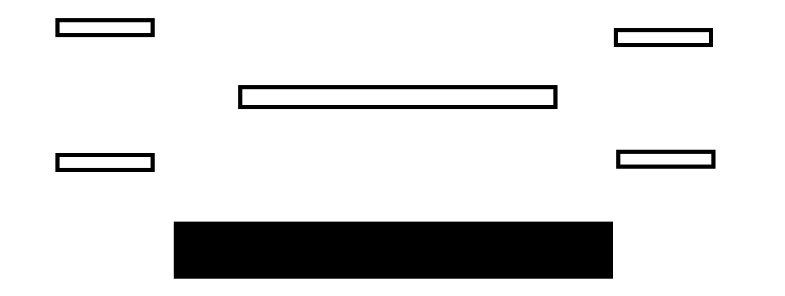

#### Playstyle:

In this map blah blah blah

### Arena 2:

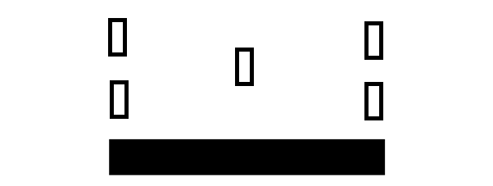

#### Playstyle:

In this arena blah blah blah

### Arena 3:

#### Playstyle:

In this map blah blah blah

## Unique Character Abilities

??

## Assets Needed

### - 2D

- Textures

- Environment Textures

- Platform Textures

- Menu Options Textures

-Characters List

- Kirby

--do we have any character unique assets (e.g special ability)

- Poppy Bro

- Knuckle Joe

### - Particles

What particles have we?

- Jump Dust

- Bomb Explosion

-

### - Sound

- Sound List

- Sound Tracks

- Sound Effects

- Menu Click

- Explosion

- Winning Sound

- Punch Sound

### - Animation

Animations are needed for all characters; the animations required are:

* Walking Left
* Walking Right
* Jumping
* Punching
* Up-Punching
* Down-Slamming
* Victory
* Etc.?